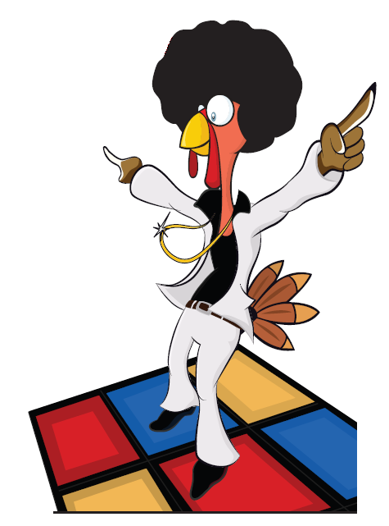

45th Annual

Squat & Gobble

Thursday, November 13th, 2024

**SPONSOR & DONOR FORM**

All proceeds benefit the victims of domestic violence and

human trafficking.

Your donation is tax deductible Under Section 501(c)3 of the Internal Revenue Code. Friends for a Cause Tax ID 51-0564841 Please consult your accountant for specifics.

**______ TITLE SPONSOR $8,000 or greater**

Premium package with customized options to fit your needs.

Contact Tommy Turk at 601-955-1677 to discuss options.

**_____ PLATINUM PILGRIM $6,000**

Private Table for 16 AND included in print advertising, web site, and banners, plus special signage at the event.

**_____ GOLDEN TURKEY $3,500**

Private table for 10 AND included in print advertising, web site, and banners, plus special signage at the event.

**_____ HAPPY HEN $1,500**

Private table for 8 AND included on website and event signage.

**_____ STUFFED TURKEY $ 800**

Private table for 6 AND included on website and event signage.

**_______ Silent Hero: A customized package can be put together that best fits your needs.**

***_______* SILENT and or Live AUCTION DONOR -** I would like to donate an auction item to the 44th Annual Squat & Gobble! *Please contact me to schedule pickup of auction item.*

_____________________________________ Retail Value___________

Contact Name: _______________________ Name to appear as Sponsor: ________________________

Address: _______________________________________________________________________

Phone: _______________________ email: _______________________________________

Please send checks payable to: Friends for a Cause, P. O. Box 2912, Madison, MS 39130-0129